
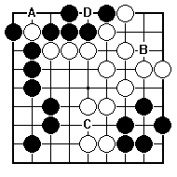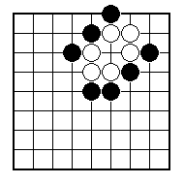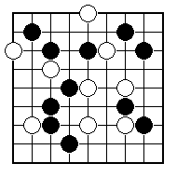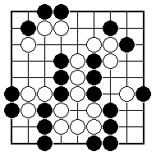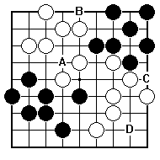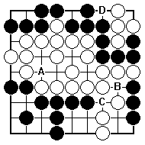
Black to play and put some white stones in atari.

Which is the white stone that Black can put in atari?

Black to play and put some white stones in atari.

Which black play would put Black’s own stones in atari – is it A, B, C or D?
Which black play would put Black’s own stones in atari – is it A, B, C or D?

Which black play would put Black’s own stones in atari – is it A, B, C or D?

NAME:
BRITISH GO ASSOCIATION CERTIFICATE LEVEL 1 - SHEET 4

ATARI

